|  |  |
| --- | --- |
| Faculty of Computer & Information Sciences  Ain Shams University  Subject: Math 4  Year: (2nd ) undergraduate  Academic year: 2nd term 2019-2020 |  |

**Research Topic (3)**

**Title: Constant-Harvest Model**

**Introduction about Ordinary differential equation (**Ref. 1**)**

A differential condition is a equation, where the obscure is a function and both the function and its derivatives may show up in the equation. Differential conditions are basic for a scientific depiction of nature— they lie at the core of many physical theories. For example, let us just mention Newton’s and Lagrange’s equations for classical mechanics, Maxwell’s equations for classical electromagnetism, Schrodinger’s equation for quantum mechanics, and Einstein’s equation for the general theory of gravitation. We now show what differential equations look like.

**List essential equations to solve initial value problem using Laplace transform** (Ref. 2)

|  |  |
| --- | --- |
| **f(t)= $L^{-1}$ {F(s)}** | **F(s)=L{f(t)}** |
| * 1 | $$\frac{1}{s}$$ |
| $e^{at}$ | $$\frac{1}{s-a}$$ |
| $t^{n}$* ,n=1,2,3,… | $$\frac{n!}{s^{n+1}}$$ |
| $t^{p}, p>-1$ | $$\frac{Γ\left(p+1\right)}{s^{p+1}}$$ |
| $\sqrt{t}$ | $$\frac{\sqrt{π}}{2s^{\frac{3}{2}} }$$ |
| $t^{n-\frac{1}{2}}$* , n=1,2,3,… | $$\frac{1⋅3⋅5⋯\sqrt{π}}{2^{n}s^{n+\frac{1}{2}} }$$ |
| * sin(at) | $$\frac{a}{s^{2}+a^{2}}$$ |
| * cos(at) | $$\frac{s}{s^{2}+a^{2}}$$ |
| * t sin(at) | $$\frac{2as}{{(s^{2}+a^{2})}^{2}}$$ |
| * t cos(at) | $$\frac{s^{2}-a^{2}}{{(s^{2}+a^{2})}^{2}}$$ |
| * sin(at)−at cos(at) | $$\frac{2a^{3}}{{(s^{2}+a^{2})}^{2}}$$ |
| * sin(at)+at cos(at) | $$\frac{2{as}^{2}}{{(s^{2}+a^{2})}^{2}}$$ |
| * cos(at)−at sin(at) | $$\frac{s(s^{2}-a^{2})}{{(s^{2}+a^{2})}^{2}}$$ |
| * cos(at)+at sin(at) | $$\frac{s(s^{2}+{3a}^{2})}{{(s^{2}+a^{2})}^{2}}$$ |
| * sin(at + b) | $$\frac{s\sin\left(b\right)+a cos⁡(b)}{s^{2}+a^{2}}$$ |
| * cos(at + b) | $$\frac{s\cos\left(b\right)-a sin⁡(b)}{s^{2}+a^{2}}$$ |
| * sinh(at) | $$\frac{a}{s^{2}-a^{2}}$$ |
| * cosh(at) | $$\frac{s}{s^{2}-a^{2}}$$ |
| $e^{at}$* sin(bt) | $$\frac{b}{{(s-a)}^{2}+b^{2}}$$ |
| $e^{at}$* cos(bt) | $$\frac{s-a}{{(s-a)}^{2}+b^{2}}$$ |
| $e^{at}$* sinh(bt) | $$\frac{b}{{(s-a)}^{2}-b^{2}}$$ |
| $e^{at}$* cosh(bt) | $$\frac{s-a}{{(s-a)}^{2}-b^{2}}$$ |
| $t^{n}e^{at} , n=1,2,3,…$ | $$\frac{n!}{{(s-a)}^{n+1}}$$ |
| $f$* (ct) | $$\frac{1}{c} F( \frac{s}{c} )$$ |
| * uc(t)=u(t−c) | $$\frac{e^{-cs}}{s}$$ |
| * δ(t−c) | $$e^{-cs}$$ |
| * uc(t) f(t−c) | $$e^{-cs} F(s)$$ |
| * uc(t) g(t) | $e^{-cs}$ L { g(t+c) } |
| $e^{ct}f(t)$ | F(s−c) |
| $t^{n}f\left(t\right), n=1,2,3,….$ | $${(-1)}^{n} F^{\left(n\right)}(s)$$ |
| $\frac{1}{t}f(t)$ | $$\int_{s}^{∞}{F\left(u\right) du}$$ |
| $\int_{0}^{t}{f\left(v\right) dv}$ | $$\frac{F (s)}{s}$$ |
| $\int_{0}^{t}{f\left(t-τ\right) g\left(τ\right)dτ}$ | F(s) G(s) |
| $f$* (t + T) = $f$ (t) | $$\frac{\int_{0}^{T}{e^{-st} f\left(t\right) dt}}{1-e^{-sT}}$$ |
| $f'(t)$ | S F(s) − $f$ (0) |
| $f$* ′′(t) | $s^{2} F\left(s\right)-s f$ (0)- $f'(0)$ |
| $f^{(n)}$* (t) | $s^{n} F\left(s\right)-s^{n-1} f$ (0)- $s^{n-2} f^{'}\left(0\right)⋯-s f^{(n-2)}$ (0)- $f^{(n-1)}$ (0) |

**Discuss the constant –Harvest Model an explain the meaning of each term in the equation.**

$$\frac{dp}{dt}=kP-h$$

This equation shows up the population of fishery over the time, and shows what will happen from increasing, decreasing or be constant

**The terms in the equation:**

P(t) :the population of fishery

P0 : the initial population

h :harvest rate (decreases the population)

K : growth rate

dp / dt : rate of change of population with time

**Solve the Constant-Harvest Model, Solve the DE subject to P(0) =P0**

We have a population P(t) for a fishery in which harvesting takes place at a constant rate is described by differential equation

$$\frac{dP}{dt}=kP-h$$

With the condition P (0) = P0

And we have to solve it as following:

This differential equation is a first order and separable D.E. then we can solve it as

$$\frac{dP}{kP-h} = dt \int{\frac{1}{kP-h} dP= }\int{dt }$$

$dfrac1k \int{\frac{k}{kP-h} dP= }\int{dt }$

ln (kP - h) = k t + c1 $e^{ln⁡(kP - h)}= e^{k t+c1}$

k P – h = $e^{c1} e^{k t}$

k P = c $e^{k t}$ + h

Then we have

P = n $e^{k t}$ + $\frac{h}{k}$ (1)

After that, to find the value of constant n, we have to apply the point of condition (P , t) = (P0 , 0) into equation (1), then we have

P0 = n $e^{0}+ \frac{h}{k}$

Then we have

C = P0 - $\frac{h}{k}$

After that, substitute with the value of constant n into equation (1), then we have

P = (P0 - $\frac{h}{k}$) $e^{k t}$ + $\frac{h}{k}$ (2)

is the population of the fishery at time t .

**Describe the behavior of the population P(t) for increasing time in the three cases:**

1. **P (0) > h/k :**

We find that the R.H.S is increasing, then the population of the fishery keeps on increasing.

1. **P (0) = h/k :**

We find that the R.H.S equals h/k, then the population becomes constant, P = P0

1. **P (0) < h/k :**

We find that the R.H.S is decreasing, then the population of the fishery keeps on decreasing.

In (C) The fish population will got extinct for the third case ( 0 < P0 < $\frac{h}{k}$).

**Use results from part B to determine whether the fish population will ever go to extinct in finite time, that is, whether there exists a time T>0 such that P(T)=0. If the population goes to extinct, then find T.**

the time to extinct:

p=(p0 - $\frac{h}{k}$) $e^{k t}$ + $\frac{h}{k}$

p=0

- = (p0- $\frac{h}{k}$) $e^{k t}$

$e^{k t}$ = - $\frac{h}{k}$ (p0 - $\frac{h}{k}$)

$e^{k t}$ = $\frac{h}{(k(h/k-p0)) }$

let to affect ln() of two sides

ln($e^{k t}$)=ln( $\frac{h}{(k(h/k-p0)) }$)

t(extinct)=($\frac{1}{k}$) ln ( $\frac{h}{(h-kp0) }$)

at case B

p0= $\frac{h}{k}$

-> t is not exist

-> the population can't extinct in the case B.

**Graph P(t) versus time t. Your graph must show the three cases mentioned in question number 5. (**Ref. 3**)**

A) P (0) > h/k

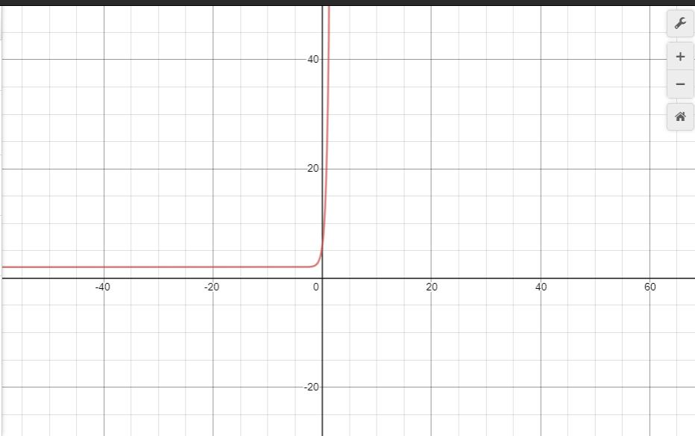

B) P(0) = h/k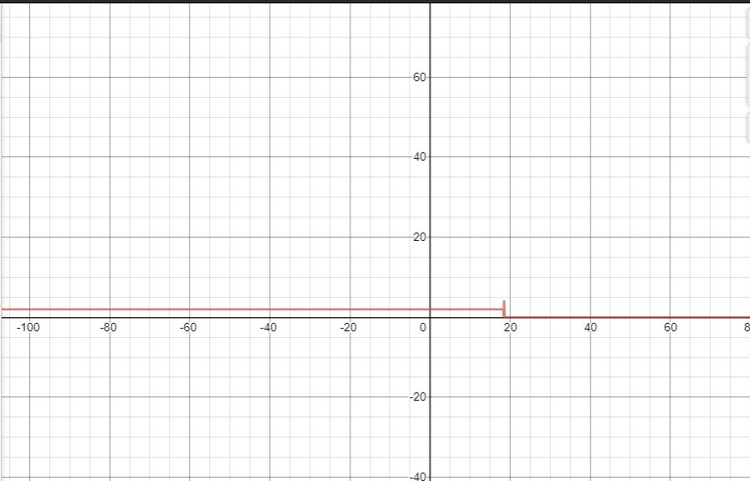

C) P (0) < h/k

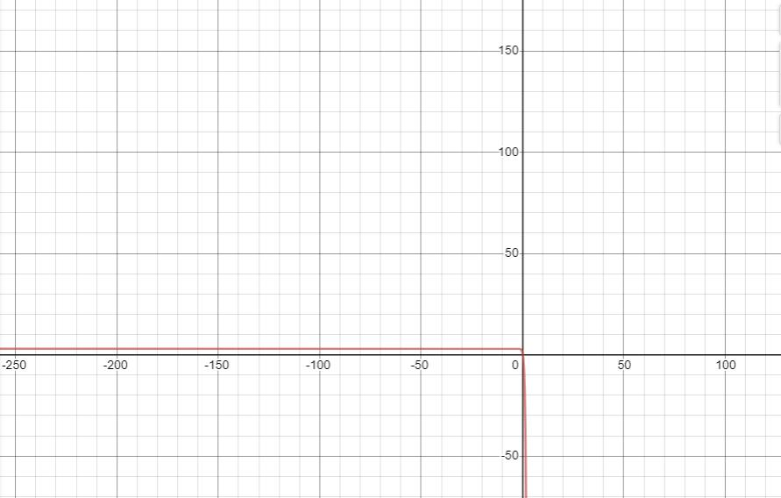

**Conclusion**

Differential equations plays major role in applications of sciences and engineering. It arises in wide variety of engineering applications for e.g. electromagnetic theory, signal processing, computational fluid dynamics, etc. These equations can be typically solved using either analytical or numerical methods. Since many of the differential equations arising in real life application cannot be solved analytically or we can say that their analytical solution does not exist. For such type of problems certain numerical methods exists in the literature. In this book, our main focus is to present an emerging meshless method based on the concept of neural networks for solving differential equations or boundary value problems of type ODE’s as well as PDE’s.

**Reference:**

[1] **Math Insight** (Website): [Link](https://mathinsight.org/ordinary_differential_equation_introduction)

[2] **Pauls Notes** (Website): [Link](https://tutorial.math.lamar.edu/Classes/DE/Laplace_Table.aspx)

[3] **Desmos** (Website): [Link](https://www.desmos.com/calculator/dffgfp3ses)

[4] **Khan Academy** (Website): [Link](https://www.khanacademy.org/math/differential-equations)

# [5] “ A First Course in Differential Equations: With Modeling Applications “ 9th Edition (Book): [Link](https://www.amazon.com/First-Course-Differential-Equations-Applications/dp/0495108243/ref=pd_sbs_14_2/130-8670654-2888803?_encoding=UTF8&pd_rd_i=0495108243&pd_rd_r=b6fe698f-dbc7-470f-b2d6-84adcd17be6f&pd_rd_w=wMavm&pd_rd_wg=HZ0N6&pf_rd_p=12b8d3e2-e203-4b23-a8bc-68a7d2806477&pf_rd_r=J9QBVXH6K85QH9MTHHE8&psc=1&refRID=J9QBVXH6K85QH9MTHHE8)